IDEATION PHASE

BRAINSTORM & IDEA PRIARITIZATION

|  |  |
| --- | --- |
| Date | 19 OCTOBER 2023 |
| Team ID | NM2023TMID01888 |
| Project Name | BIOMETRIC SECURITY SYSTEM FOR VOTING PLATFORM |
| Maximum Marks | 4 Marks |

# Brainstorm & Idea Prioritization:

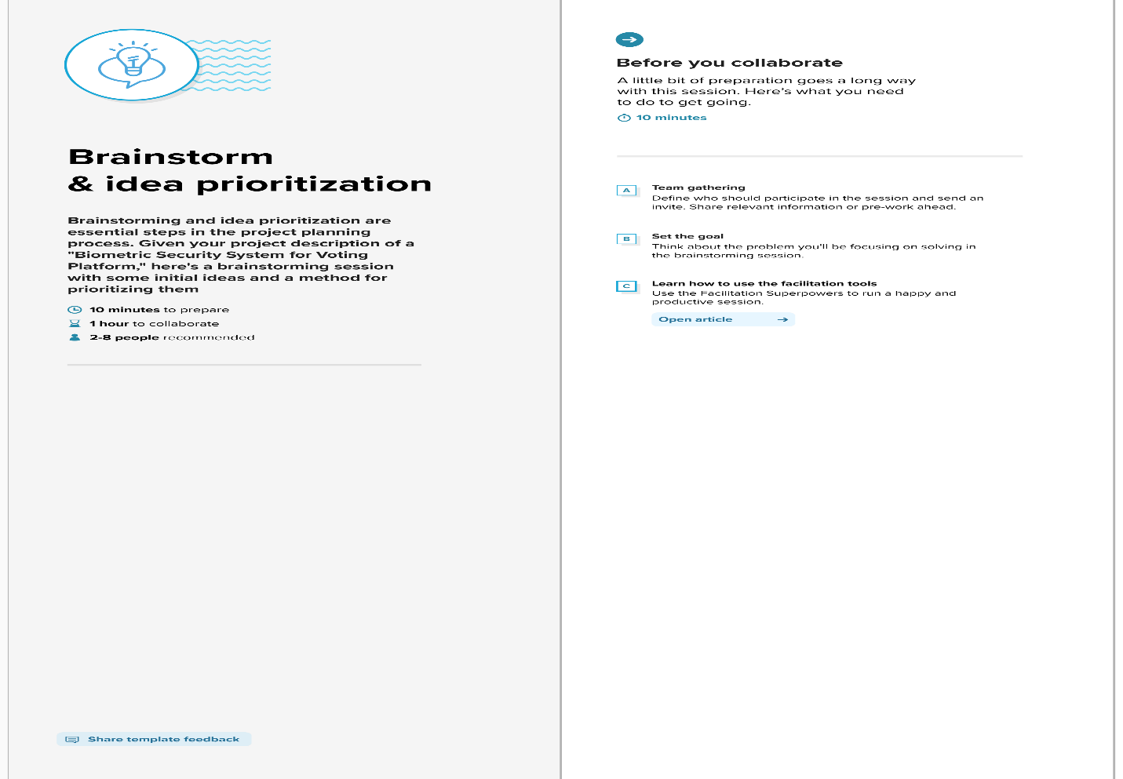

**Step-2: Brainstorm, Idea Listing and Grouping**

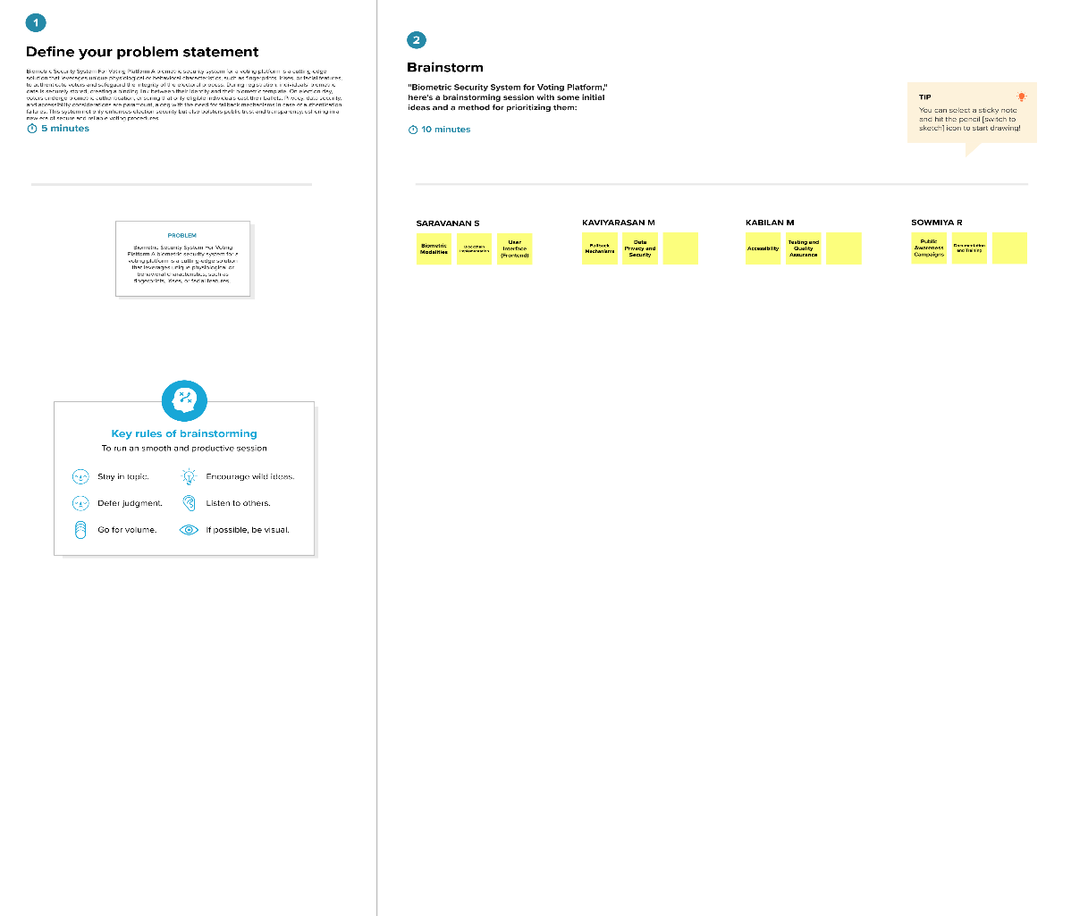

**Step-3: Idea Prioritization**

